ROSE PRUNING
WORKSHOP
- Sunday, January 22, 2-4pm
- Colusa Co Fairgrounds, Grandstand
- Bring pruners, loppers, saw and gloves
- Master Gardeners of Colusa County
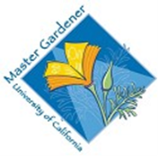
*Everyone Welcome*

