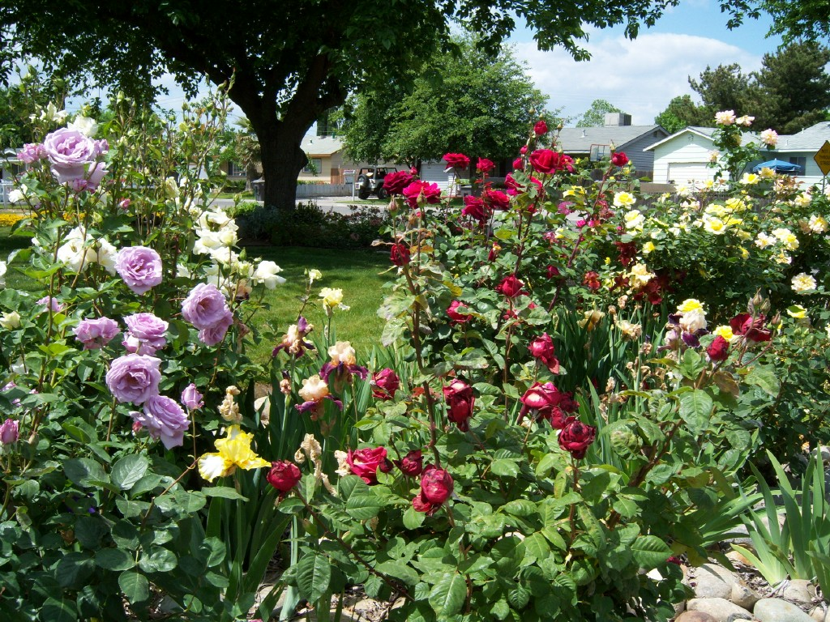
ROSE PRUNING
WORKSHOP, TODAY
January 27, 2-4pm
Colusa County Fairgrounds, grandstand

