**In This Issue**

MCj03312650000[1]

* Practices to consider in prune orchards in July/August
* Earlier harvest in 2013
* 2013: A Tough Year for Cankers

**Submitted by:**

Franz Niederholzer

UC Farm Advisor

Sutter-Yuba, Colusa Counties

**ANR NONDISCRIMINATION AND AFFIRMATIVE ACTION POLICY STATEMENT FOR UNIV OF CALIFORNIA** The Univ of California Division of Agriculture & Natural Resources (ANR) prohibits discrimination or harassment of any person in any of its programs or activities (Complete nondiscrimination policy statement can be found at http://ucanr.org/sites/anrstaff/files/107778.doc). Inquiries regarding ANR’s equal employment opportunity policies may be directed to Linda Marie Manton, Affirmative Action Contact, Univ of California, Davis, Agriculture and Natural Resources, One Shields Avenue, Davis, CA 95616, (530) 752-0495. Cooperative Extension provides reasonable disability accommodations for those who require such assistance. Please request your accommodation needs at least two weeks prior to an event by calling 530-822-7515. June, 2010

**Suggested prune orchard activities in July and/or August**

* **Time harvest using fruit pressure measurements.**  Picking too early leaves money on the table. Picking too late leaves money on the orchard floor.
* **Clean up your refractometer and fruit pressure gauge**. If you don’t own these essential tools for effective prune harvest, buy them. A fruit pressure gauge costs about $300. A refractometer for sugar measurement costs $150-$300. See article in this newsletter about 2013 harvest timing.
* **Run a field sizer** on your harvester this year. Delivering certain small sized fruit to the dryer will cost you money. Check with your processor regarding prices or expected prices. What fruit will be worth what? KEY POINT: Don’t rely only on fresh fruit size when deciding what size chain to run. Know your sugar levels at harvest and use this information to select chain size. Why? Sweeter fruit dries to a larger count prune than fruit of the same fresh size, but less sugar. For example: a fresh prune with 28% sugar will be 8-13 counts **larger** when dried to 18% moisture than a fruit of the same fresh size, but with 20% sugar.
* **Preharvest irrigation water shut off**. Properly timed irrigation cut off will help reduce 1) bark damage from shakers, 2) fruit dry-away ratio, and 3) premature fruit drop. Use fruit pressure information to predict start of harvest (fruit pressure drops 1-2 pounds/week; ideal harvest pressure = 3-4 pounds fruit pressure) and then use that date to decide when to cut-off irrigation water before harvest. UC research and experience in this region in 2006 shows that healthy prune trees can sustain water cut off for up to six weeks before actual harvest. Grower experience should determine when irrigation water is cut off in a specific orchard. Wet orchards show the most premature fruit drop when night-time temperatures drop to around 50oF.
* **Preharvest brown rot sprays** may reduce fruit brown rot in orchards where brown rot has been or might be a problem. Consult with your PCA regarding materials and timing. Adding 1% oil to a preharvest fungicide has improved fruit brown rot control in research conducted by UC.
* **Watch pests and tree water status.** Monitor blocks for spider mites, rust, and water status. If spider mite pressure is building right before harvest, consider a potassium nitrate spray to “top off” the potassium levels in the trees and suppress adult spider mites for 2-3 weeks.
* **Clean up orchard before harvest**. Cut out dead and dying limbs, suckers, etc. prior to harvest. This will reduce harvester and/or tree damage and make for a faster, cleaner harvest. See article in this newsletter.
* **Take leaf samples in July**. Key nutrients to check are nitrogen, potassium, and zinc. Add add chloride to the analysis request if you use muriate of potash (potassium chloride) as a potassium fertilizer. Call Franz for details on how to take samples. See table of critical values for summer leaf analysis results in this newsletter.

MCj03312650000[1]

**Earlier harvest in 2013?**

*Franz Niederholzer, UC Farm Advisor, Colusa/Sutter/Yuba Counties*

Will the warm spring this year result in earlier prune harvest? The UC Harvest Prediction Model suggests that harvest will be several weeks earlier than the last few years. What does that mean for growers? Harvest will be when the fruit is ready, but it is a good idea to consider the following:

* **Don’t let harvest sneak up on you**. Knowing the general timing of harvest in different blocks allows for more accurate and effective irrigation shut off and orchard dry-down ahead of harvest, timely equipment maintenance/preparation, and better harvest planning in general.
* **Track fruit maturity and sugar content once first color shows in fruit**. Fruit is generally mature a month after first color shows. The best indication of fruit maturity is fruit pressure. Fruit sugar levels do not accurately reflect fruit maturity. Check with local farm and orchard supply stores for “Fruit Pressure Tester”. These devices cost about $300/ea. If that cost seems too high, why not split the cost with a neighbor? Fruit pressure should be checked about once a week, leaving plenty of time for sharing a pressure tester between two or more operations. Every prune grower should have ready access to this tool. Fruit is mature between 3-4 lbs internal pressure.

There is no more important time in an orchard business than harvest. Proper harvest timing results in the best return to the grower from delivering the highest quality fruit possible under the conditions of that season. Harvesting too early leaves money in the orchard due to higher dry-away and lower yield. Harvesting too late means running the risk of fruit drop on the orchard floor if wind, rain, and/or cool weather occur suddenly. Not all the crop can be harvested at optimum maturity, but careful planning will give you the best overall results.

MCj03312650000[1]

**Blue Prune Drop and Leaf Scorch**

*Bill Krueger UC Farm Advisor-Emeritus, Glenn County*

*Richard Buchner UC Farm Advisor, Tehama County*

Blue prune and, in some cases, an associated leaf scorch often develops following the rapid onset of high temperatures as occurred in June of this year (Figure 1). Damaged prunes color prematurely (turn blue) and usually drop from the tree. The more sun exposed fruits on the top or south side of the tree are more affected. Often the sun exposed side of the fruit will be sunken or flattened. Leaf scorch and die back may develop in leaves and twigs near the damaged fruit. When damaged leaves dry, the veins may be a darker brown than the rest of the leaf.

Blue prune is associated with heat stress. Excessive heat results in damage to the fruit that is thought to produce a toxin which is transported to spurs, leaves and shoots resulting in the leaf scorch symptoms. Leaf scorch symptoms are always associated with damaged prunes. They do not occur in areas of the tree with no fruit or on young trees without a crop. Anything affecting fruit temperature can have an effect. This would include:

1. Irrigation – Drop and particularly scorch are generally more severe on shallow soils with limited water holding capacity or in orchards toward the end of their irrigation cycle at the onset of heat. Adequate soil moisture insures maximum evapotranspiration and cooling of the plant.

2. Tree Position or Fruit Location - Leaf scorch is usually worse on border trees, or on the south side of individual trees with greater sun exposure.

3. Cultural Practices – Blue prune appears to be less severe in orchards with cover crops than in clean tilled or drip irrigated orchards. Transpiration from an adequately irrigated cover crop should contribute to orchard cooling. In addition, a vegetated orchard floor reflects less sunlight than dead vegetation or bare ground.

4. Nutrition - While blue prune and leaf scorch does not appear to be directly related to potassium deficiency, anything adversely affecting tree health and condition could contribute to higher fruit temperatures. Adequate tree nitrogen levels promote vegetative growth that shades fruit from direct sunlight.

We don’t have any sure ways of preventing blue prune and the associated leaf scorch. However, you can reduce the risk by making sure trees are healthy, vigorous and well supplied with water. Because the damage is caused by heat and not a disease, it should not continue to expand in the tree. Damaged wood should be pruned out during the dormant season.

Figure 1. Maximum temperature records (degrees Fahrenheit) for four CIMIS weather stations located in the Sacramento Valley of California, 2013.

|  |  |  |  |  |
| --- | --- | --- | --- | --- |
|  | **Tehama** | **Butte** | **Colusa** | **Sutter** |
| **Date** | **CIMIS #8** | **CIMIS #12** | **CIMIS #37** | **CIMIS #235** |
| June 5 | 88 | 85 | 87 | 87 |
| June 6 | 95 | 89 | 92 | 92 |
| June 7 | 104 | 104 | 105 | 104 |
| June 8 | 105 | 103 | 107 | 106 |
| June 9 | 89 | 85 | 86 | 87 |



Figure 2. Blue prune and leaf scorch symptoms showing damaged fruit, scorched leaves and darkened leaf veins

**2013: A Tough Year for Cankers**

*Franz Niederholzer, UC Farm Advisor, Colusa/Sutter/Yuba Counties*

*and Joe Connell, UC Farm Advisor, Butte Co.*

It has been a difficult year for the canker diseases [bacterial canker](http://ipm.ucdavis.edu/PMG/r606100711.html) and [cytospora](http://ipm.ucdavis.edu/PMG/r606100311.html) in prune orchards in the Sacramento Valley. Both of these diseases are most damaging in stressed orchards and there are no known simple cures for either infection. This article will briefly review management practices for these two damaging diseases.

Bacterial Canker is a disease of stressed trees and is especially damaging in stone fruit orchards. Tree damage occurs exclusively above ground, but the disease is promoted by stressful soil conditions. The stress can come from many sources including root feeding nematodes, shallow hardpan, and/or low soil nitrogen levels. The damaging bacteria (*Pseudomonas syringae*) are naturally present and normally live harmlessly on the surface of trees and weeds throughout an orchard. Tree infections occur during wet and/or cold winter and spring conditions through natural and unnatural openings in the tree such as bark pores (lenticels), opening flowers, pruning cuts, etc. Bacterial canker usually strikes young trees – 2nd to 8th leaf – in a certain region of the orchard where soil conditions result in tree stress. The disease does not survive in the tree from year to year, but the potential for another infection remains as the disease organism is always present, waiting for the “right” conditions to infect once again.

What can be done to prevent or stop bacterial canker disease? Unfortunately, there are no practices that prevent or eliminate the disease. The following practices have been shown to reduce bacterial canker damage in prune orchards in California, but not eliminate the problem:

* **Control nematodes**: Fumigate an orchard site when preplant soil samples show the presence of root feeding nematodes, especially ring nematode. Fumigation will not eliminate the risk of bacterial canker developing in the orchard. For established orchards, discuss labeled options for post-planting nematode management with your PCA.
* **Choose a less susceptible rootstock**: Where possible, plant on Lovell peach rootstock. Trees grown on this rootstock are less susceptible to bacterial canker than those grown on plum (M2624, M29C, Myro seedling, etc.) rootstocks. If the soil is too heavy for peach rootstock, use M40 plum root, the least susceptible of the plum rootstocks tested to date. Trees budded high, around 32” above the soil level, have shown the least bacterial canker infection in field studies in the Sacramento Valley. At least one grower in the region has ordered all his replants budded high.
* **Maintain soil fertility**, especially nitrogen (N). Prune trees deficient in N are more susceptible to bacterial canker infection than trees with adequate N status. High to excessive plant N status provides no additional benefit from bacterial canker compared to adequate N levels and can aggravate other diseases such as brown rot. Use of slow release, multi-nutrient fertilizers has shown benefit in UC research.

Cytosporacanker is a weak pathogen caused by the fungus *Cytospora leucostoma*. Disease spores are spread by wind and rain to bark damaged by other stresses, particularly sunburn. The fungus shows maximum growth in hot temperatures around 90oF and is particularly active in late summer to early fall. Trees planted on shallow and/or heavy textured (clay) soils are generally more likely to suffer economic damage since 1) these soils can be low in plant available K and 2) the disease spreads more rapidly in water stressed trees.

There are no chemical controls for cytospora cankers. To manage infection and reduce disease spread, avoid tree stress and remove cankered wood from the orchard and burn it. Prune to minimize sunburn potential (leave more upright branches), and, paint exposed trunks and scaffold crotches with white interior latex paint to further protect them from sunburn. Maintain adequate orchard water status, especially after harvest, and avoid potassium deficiency, spider mite or prune rust defoliation that can increase sunburn and disease potential.

Cytospora can be a major problem in older blocks. In these blocks, consider preharvest or postharvest “clean up” pruning with saws only, no loppers, using a trained crew exclusively focused on removing damaged scaffolds. This practice will reduce cytospora in the orchard and allow replacement branches to develop. If this work is done prior to harvest, removal of dead branches that can break and damage equipment during harvest will result in a smoother, less costly harvest.

To identify limbs killed or weakened by cytospora cankers, look for dark, sunken cankers on the bark of limbs showing dieback or branches where dead leaves are still attached. Cankers will have distinct zonate margins (Figure 1) that are different from the streaking and flecking in the tissue that is characteristic of bacterial cankers. Small white spots called pychnidia found on dead wood will confirm the presence of *Cytospora* (Figure 2).

Pruning out diseased limbs and burning them will reduce disease pressure and spores that can spread disease to new wood next season. Be sure to cut into healthy wood several inches to one foot below **any** canker symptoms. Check the cut surface of damaged limbs to ensure that all disease has been removed (Figure 3). Incomplete canker removal won’t control the disease, thus wasting the time and money spent pruning. Ruthless pruning is most cost effective in the long run. Don’t leave dead wood in the tree just because it has tree rope or wire attached to it. Chances are excellent that leaving this wood will hasten the spread of disease in the orchard and cost you money in the long run. Cut hard, cut hard, cut hard.

For more detailed information on disease management and for excellent photos of disease symptoms and fungus signs that will help you know what to look for, visit the IPM web page (www.ipm.ucdavis.edu) and click on Agriculture and floriculture; Prune; and cytospora canker or bacterial canker (under diseases).

**Figure 1. Cytospora cankers are detected as sunken areas on the branch where bark has been killed. Arrows point to canker edges, revealed by a knife cut in the second photo.**

Alive

Dead Spores can be spread by rain and wind and possibly by wood-boring beetles such as shot-hole borers. ead

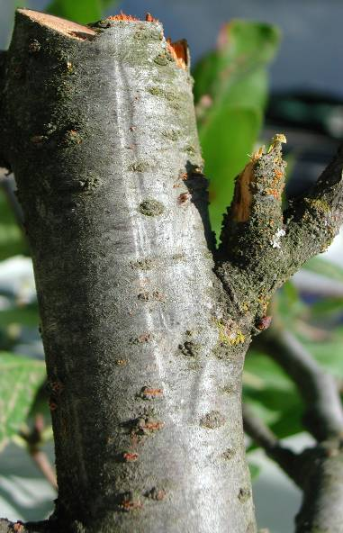 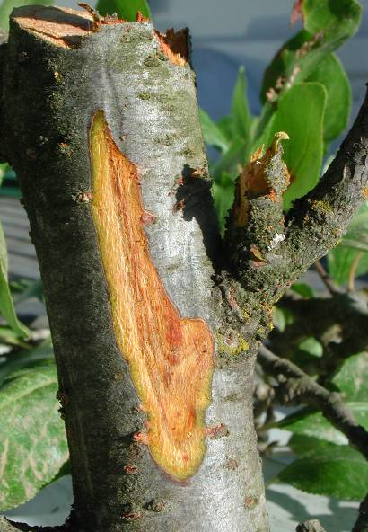

**Figure 2. Pychnidia, black or white pimple-like spore producing structures, found on dead wood.**

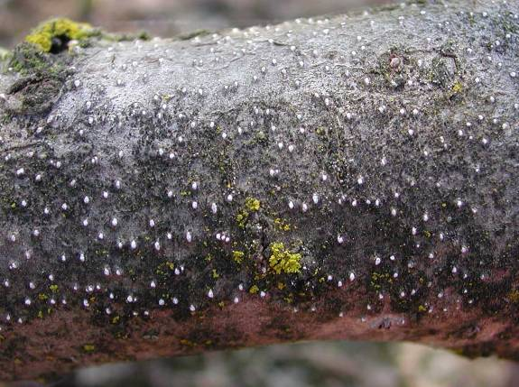

**Figure 3. Good cut (1) below canker showing only clean bark. Bad cut (2) not far enough down the branch showing diseased bark (arrows) remaining in the tree.**

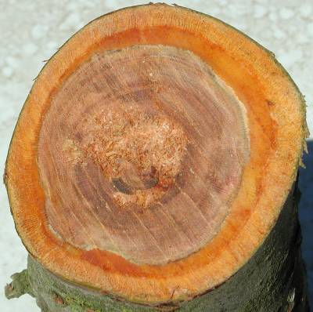 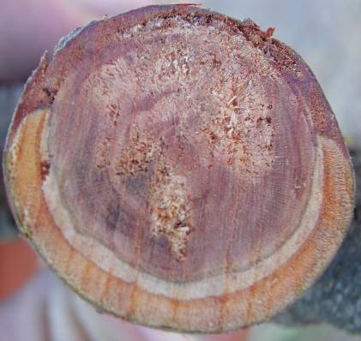

**1**

**2**

******************************************************************************

Critical nutrient levels (on a dry weight basis) for nonbearing spur leaves of ‘French’ prune sampled in July. Information on key nutrients is shaded.

|  |  |  |  |
| --- | --- | --- | --- |
| **Nutrient** | **Excessive level** | **Adequate level** | **Deficient level** |
| Nitrogen | over 2.8% | 2.3% - 2.8% | below 2.2% |
| Phosphorus | -- | 0.1% - 0.3% | -- |
| Potassium | over 2.0% | 1.3% - 2.0% | below 1.0% |
| Calcium | -- | over 1.0% |  |
| Magnesium | > | over 0.25% |  |
| Sodium | over 0.2% |  |  |
| Sulfur* | -- | Over 0.15%* | Under 100 ppm  SO4-2 - S* |
| Chlorine | over 0.3% | -- | -- |
| Boron | over 100 ppm | 30-80 ppm | under 25 ppm |
| Manganese |  | over 20 ppm | -- |
| Copper |  | over 4 ppm | > |
| Zinc | -- | -- | under 18 ppm |

*Use fully expanded shoot leaves, not spur leaves