Virtual Healthy Soils Compost Field Day
July 28, 2021
9:00-10:00am

9:00 am Welcome and Introduction
Amber Vinchesi-Vahl, UCCE Vegetable Crops Advisor-Colusa, Sutter and Yuba Counties

9:10 am Impact of soil health practices on survival of soilborne plant pathogens
Kelley Paugh, Postdoctoral Research Scientist, Department of Plant Pathology, UC Davis

9:20 am Estimating N mineralization (or availability) from compost
Margaret Lloyd, UCCE Small Farms Advisor-Yolo, Solano and Sacramento Counties
Daniel Geisseler, Nutrient Management Specialist, UC Davis

9:40 am Composted municipal waste amendments and tomato production: a 3-year study in Merced County
Scott Stoddard, UCCE Vegetable Crops Advisor-Merced and Madera Counties

If you have any questions, please contact Amber Vinchesi-Vahl: acvinchesi@ucanr.edu or 530-458-0575.

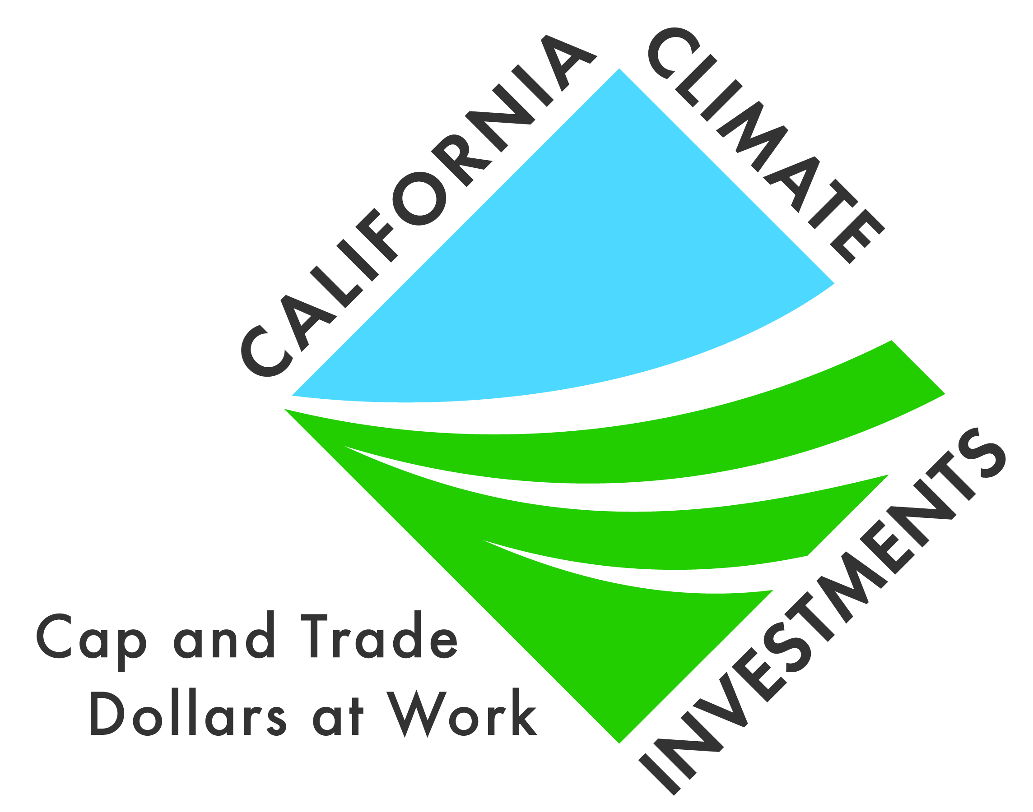
The 2020 Healthy Soils Demonstration Project is part of California Climate Investments, a statewide initiative that puts billions of Cap-and-Trade dollars to work reducing greenhouse gas emissions, strengthening the economy, and improving public health and the environment — particularly in disadvantaged communities.

